

**Reflection Report: Impact and Opportunities for the Divine Himalayan Foundation**

Submitted by : Aryan Dhasmana

23BCB10081 (BE CSE CSBS)

CBS121 - B

Email : 23bcb10081@cuchd.in

**Table of Contents**

**Introduction ………………………………………………………… 3**

**Objective ……………………………………………………………. 3**

**Daily** **Observations ………………………………………………….. 4**

* Day 1: Unveiling the Impact – Exploring Local NGOs and

Building Bridges

* Day 2: From Corporate Boardroom to Rural Revival
* Day 3: Beyond the Tourist Trail – Unveiling the

Heart of Rural Development

* Day 4: Collaboration and Community Building
* Day 5: Unveiling the NGO’s Philosophy

**Impact** **Assessment** **…………………………………………………. 9**

* Education and Youth Empowerment
* Environmental Conservation
* Cultural Preservation
* Community Building

**Challenges Faced ……………………………………………………. 9**

**Recommendations ………………………………………………….. 10**

**Conclusion ………….………………………………………………. 11**

**Appendices …………………………………………………………. 12**

**Introduction**

My week-long exploration of the Divine Himalayan Foundation (DHF) offered profound insights into their programs aimed at fostering sustainable development and community empowerment in rural Himalayan regions. Through extensive interaction with the staff, beneficiaries, and volunteers, I gained a thorough understanding of their impact, challenges, and potential areas for improvement.

**Objective**

The objective of this report is to assess the impact of the Divine Himalayan Foundation’s programs, identify areas for improvement or expansion, and provide recommendations to enhance their effectiveness in fostering sustainable development and community empowerment.

**Daily Observations**

**Day 1: Unveiling the Impact – Exploring Local NGOs and Building Bridges** **Purpose:** To initiate contact with local NGOs and understand their focus areas.

**Activities:**

* Conducted online research on various NGOs and shortlisted three for visits.
* Contacted the Divine Himalayan Foundation, the top choice on the list.
* Spoke with the president, who shared insights about their programs and personal journey from corporate life back to his native village.
* Received an invitation for an in-depth discussion at their office.

**Key Observations:**

* The president’s dedication and passion for community service were inspiring.
* Initial discussions highlighted DHF’s significant role in education, healthcare, and economic empowerment

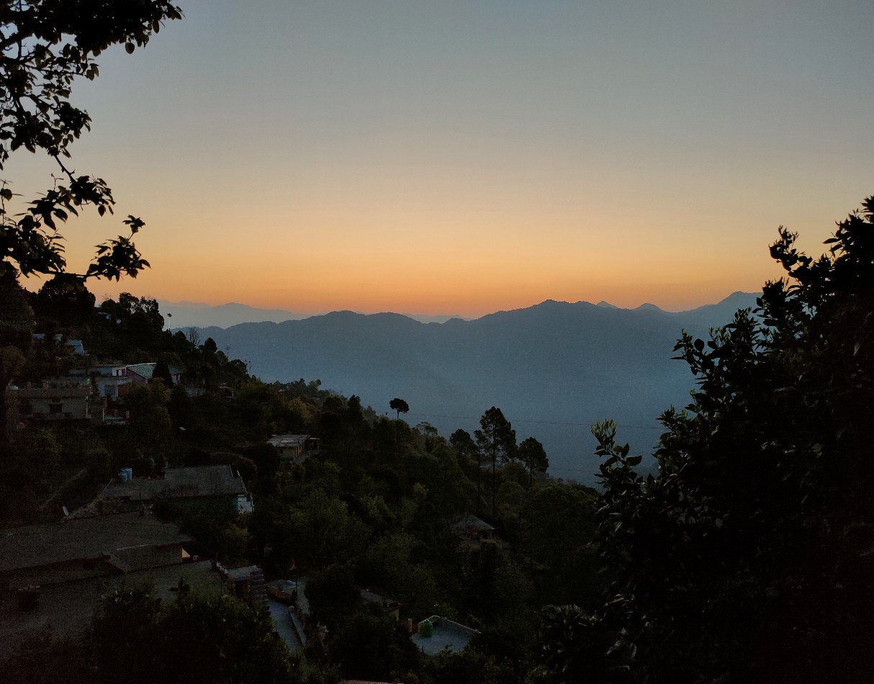

***Fig : A mesmerising Sunrise***

**Day 2: From Corporate Boardroom to Rural Revival** **Purpose:** To understand the environmental and infrastructural landscape.

**Activities:**

* Took a scenic yet challenging hike through local forest to reach the cantonment market, as recommended by a local resident. Observed the vibrant sunset and local flora and fauna.
* Encountered and befriended a stray dog, which highlighted the community's interconnectedness with its environment.

**Key Observations:**

* The experience underscored the importance of environmental conservation and eco-tourism.
* Poor transportation infrastructure was evident, emphasizing the need for better roads.

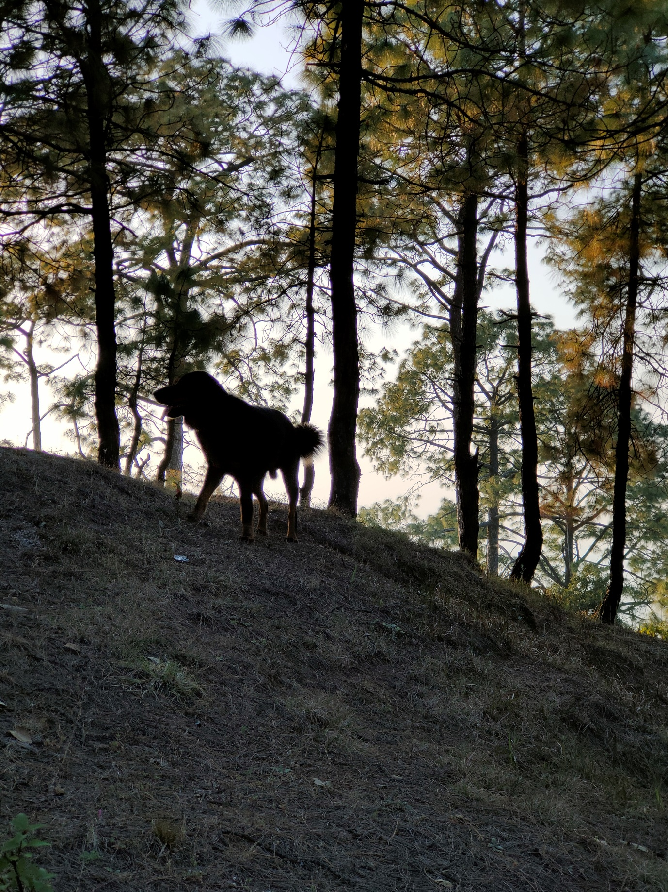

***Fig : A local canine companion***

**Day 3: Beyond the Tourist Trail – Unveiling the Heart of Rural Development** **Purpose:** To explore remote areas and understand deeper community challenges.

**Activities:**

* Ventured into the hills behind the village, discovering an abandoned village.
* Interacted with an elderly resident who shared stories of the village’s past and current struggles.

**Key Observations:**

* The stark contrast between vibrant and abandoned villages highlighted severe infrastructural and economic challenges.
* The resilience of remaining residents emphasized the need for targeted development programs.

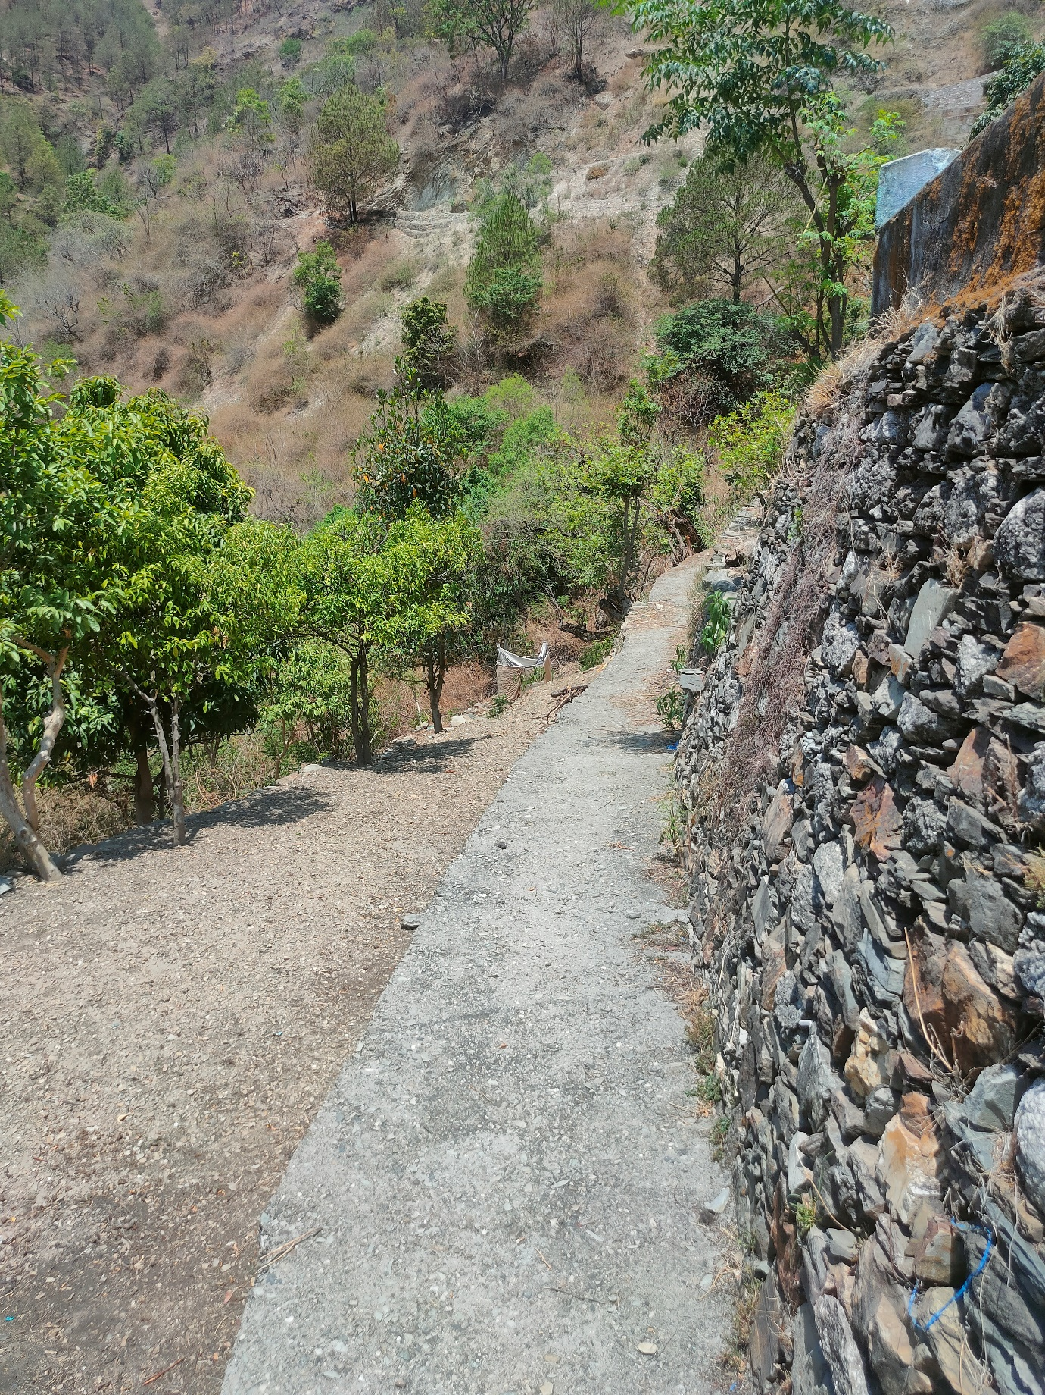

***Fig : A rural pathway***

**Day 4: Collaboration and Community Building** **Purpose:** To participate in and observe community engagement activities.

**Activities:**

* Volunteered at a local school supported by DHF, joining a retired military man’s efforts.
* Met a mother-daughter duo from Russia who were also volunteering and donating supplies.
* Organized an impromptu art session with children, bridging language barriers through creativity.

**Key Observations:**

* The collaborative art session underscored the power of community building and cross-cultural connections.
* Witnessing diverse volunteers working together highlighted the global appeal and support for DHF’s mission

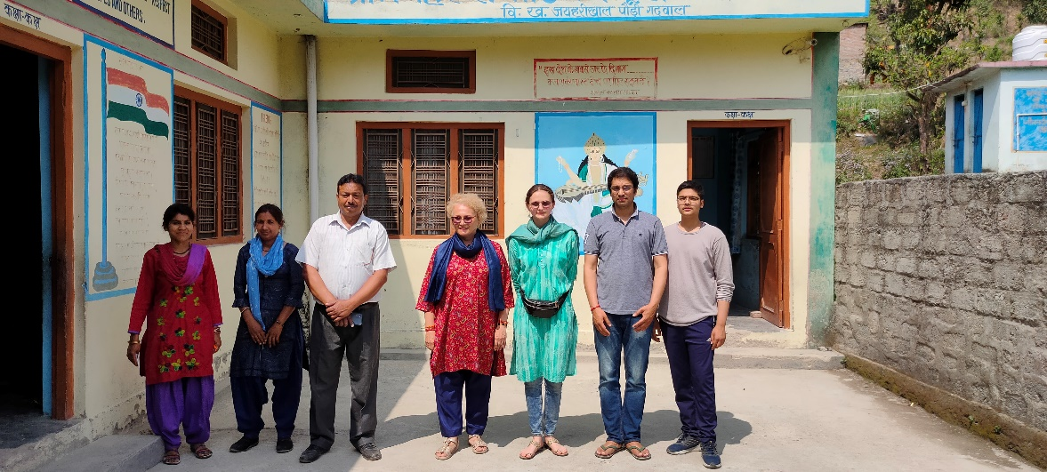

***Fig : With the school staff***

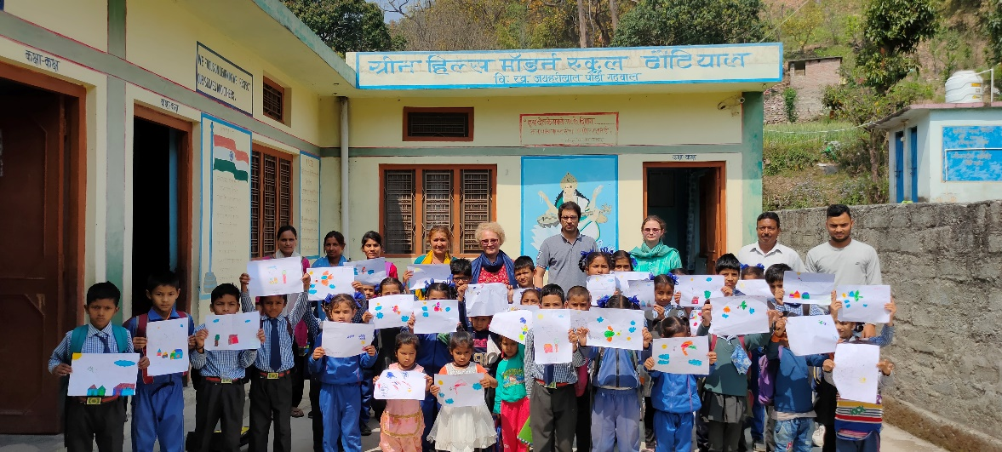

***Fig : Along with the students***

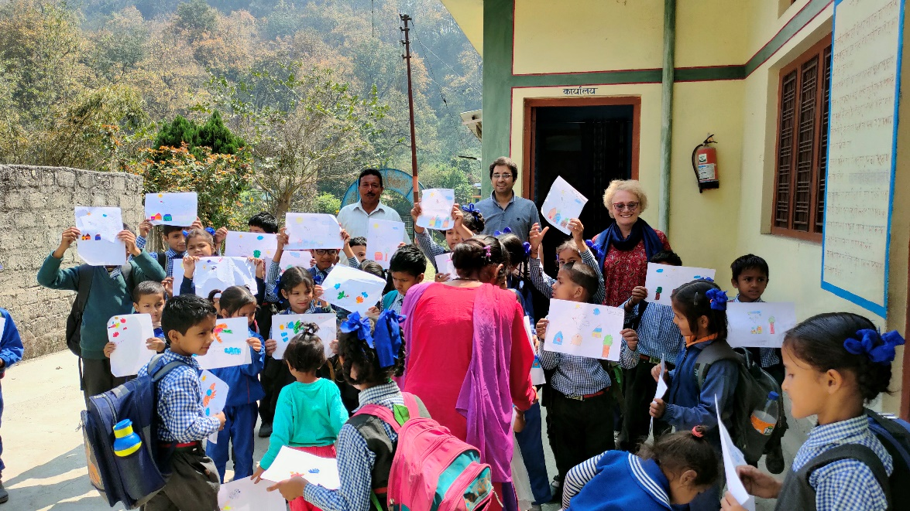

***Fig : A candid moment***

**Day 5: Unveiling the NGO’s Philosophy** **Purpose:** To gain a deeper understanding of DHF’s mission and strategies.

**Activities:**

* Engaged in a detailed discussion with the NGO’s president about their mission and core philosophy.
* Learned about their focus on eco-friendly practices and sustainable tourism.
* Concluded the meeting with a yoga session led by the president, connecting with local traditions and holistic practices.

**Key Observations:**

* The president’s vision for balancing development with environmental protection was compelling.
* The integration of traditional practices like yoga into their programs reflected a holistic approach to community well-being.

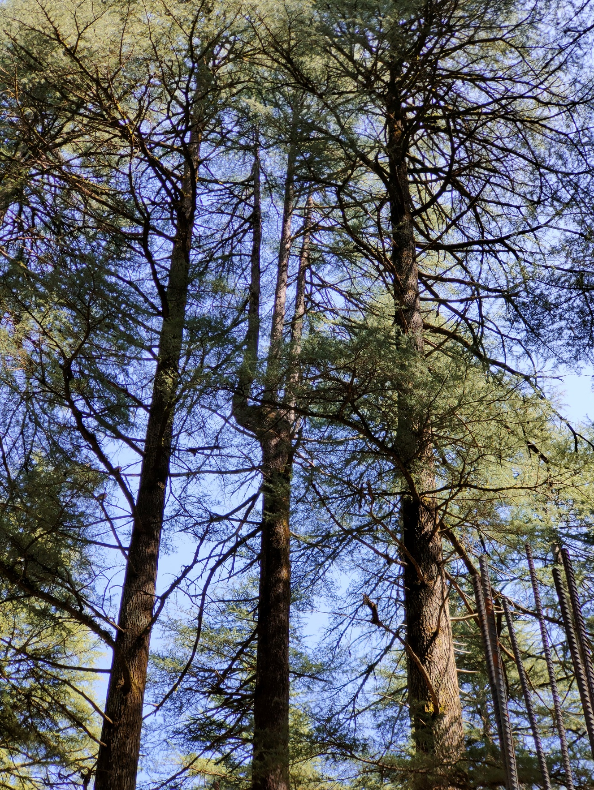

***Fig : Tall standing pine trees***

**Impact Assessment**

**Education and Youth Empowerment**

* DHF’s support for local schools and creative activities significantly enhances educational opportunities and fosters creativity among children.

**Environmental Conservation**

* Promoting eco-tourism and sustainable practices helps preserve natural beauty while generating economic benefits.

**Cultural Preservation**

* Integrating traditional practices into their programs helps maintain cultural heritage and promotes holistic well-being.

**Community Building**

* Initiatives encouraging local and international volunteerism strengthen community ties and promote cultural exchange.

**Challenges Faced**

1. **Resource Constraints:**
   * Limited funding and resources restrict program scope.
2. **Community Engagement:**
   * Ensuring sustained community involvement can be challenging.
3. **Infrastructure Development:**
   * Poor infrastructure in rural areas hampers program effectiveness.
4. **Monitoring and Evaluation:**
   * Lack of systematic frameworks limits the ability to measure impact and adapt programs.

**Recommendations**

1. **Expand Funding Sources:**
   * Develop partnerships with larger NGOs, corporate sponsors, and government bodies to secure additional funding and resources.
2. **Enhance Community Engagement:**
   * Implement more community-driven projects and regular feedback mechanisms to enhance local ownership and participation.
3. **Advocate for Infrastructure Improvements:**
   * Advocate for government support in infrastructure development and collaborate with other NGOs to pool resources for community projects.
4. **Strengthen Monitoring and Evaluation:**
   * Establish robust monitoring and evaluation systems to track progress, assess impact, and identify areas for improvement.

**Conclusion**

The Divine Himalayan Foundation is making substantial contributions to its community through education, environmental conservation, cultural preservation, and community building. Addressing challenges related to resource constraints, community engagement, infrastructure, and evaluation is essential for sustaining and expanding their impact. By leveraging partnerships, enhancing community involvement, advocating for infrastructure improvements, and implementing robust monitoring systems, DHF can further their mission and drive sustainable development in the region.

**Appendices**

1. [Government Report on Rural Infrastructure and Livelihoods: Reflections on Livelihood Impacts and Service Accessibility](https://cdn.s3waas.gov.in/s32f55707d4193dc27118a0f19a1985716/uploads/2022/11/2022111824-1.pdf)

2. [NGO Page](https://www.justdial.com/Pauri/Divine-Himalayan-Foundation-Lansdowne/9999P1368-1368-191015230729-C5D9_BZDET)

3. [Report on migration](https://www.internationaljournalcorner.com/index.php/theijhss/article/view/126887/87777)

4. [Facebook Page](https://www.facebook.com/divinehimalayan/)

5.[Location](https://g.co/kgs/C9jt19A)

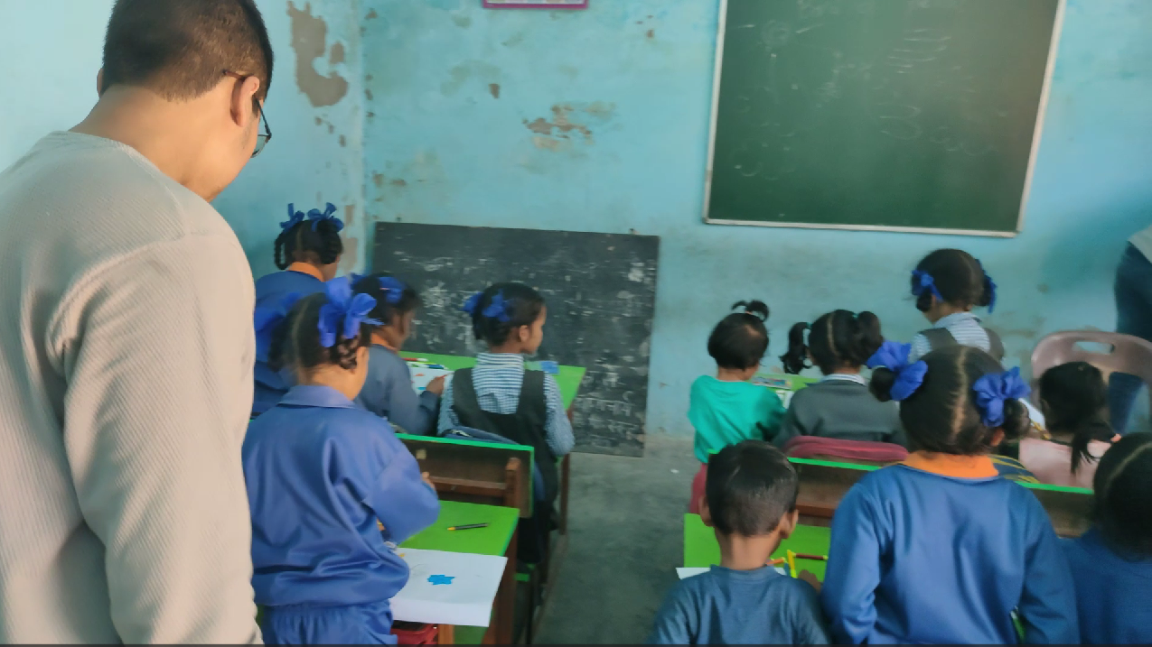

***Fig : Video thumbnail from the event.(***[***link***](https://github.com/aryan-0102/projects/tree/main/Social_Internship/Week2)***)***

**Note**: The QR code provided below links to the GitHub repository containing all the data presented in the report.

[](https://github.com/aryan-0102/projects/tree/main/Social_Internship)

This repository serves as a comprehensive resource for further exploration and analysis of the findings, recommendations, and additional data collected during the investigation. Feel free to access the repository for detailed information and to engage with the content presented in this report.